Semantic Plagiarism Detection Agent
- Team: Zero Bugs
Project Objective
To develop a user-friendly semantic plagiarism detection platform that identifies potentially suspicious similarity based on meaning, paraphrasing and sentence-level relationships rather than relying only on exact word matching.
1. Executive Summary
SemantiCheck AI is an explainable semantic plagiarism detection platform designed to help students, faculty and academic institutions investigate textual similarity more effectively. The system compares two documents or text inputs, processes their content sentence by sentence, calculates semantic similarity, identifies exact/near and paraphrased matches, and presents the findings through an easy-to-understand results interface.
The central idea is to move beyond simple keyword or exact-phrase matching. Two sentences may use different vocabulary and sentence structures while expressing essentially the same idea. SemantiCheck AI addresses this problem through semantic embeddings and similarity analysis, while keeping the final decision with a human reviewer.
2. Problem Statement – Problem Statement 5
Build a semantic plagiarism detection system that identifies similarities based on meaning rather than exact wording.
Conventional plagiarism checking can identify copied phrases effectively, but paraphrased or restructured content can be harder to investigate using only lexical overlap. The proposed system focuses on semantic similarity: understanding whether two passages convey a similar meaning even when their wording is substantially different.
Example
Original: “Students can improve their academic performance through personalized feedback.”
Paraphrased: “Individualized feedback helps learners achieve better academic results.”
The wording is different, but the underlying concept is similar.
3. Objectives
- Detect semantic similarity between two documents or text inputs.
- Identify sentence-level matches and potentially suspicious passages.
- Detect paraphrased content where wording changes but meaning remains similar.
- Combine semantic similarity with lexical comparison for richer analysis.
- Explain why a passage was flagged instead of showing only a single percentage.
- Provide visual results such as similarity indicators, match lists and heatmaps.
- Generate a structured report that can support human academic review.
- Keep the workflow simple enough for a first-time user.

4. Proposed Approach
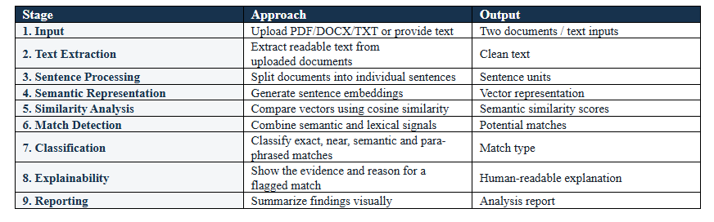
The application follows a clear document-comparison pipeline. The user uploads a reference/original document and a document to compare. The backend extracts and preprocesses the text, splits it into sentences, generates semantic representations, calculates similarity and classifies the resulting matches.

End-to-End Workflow
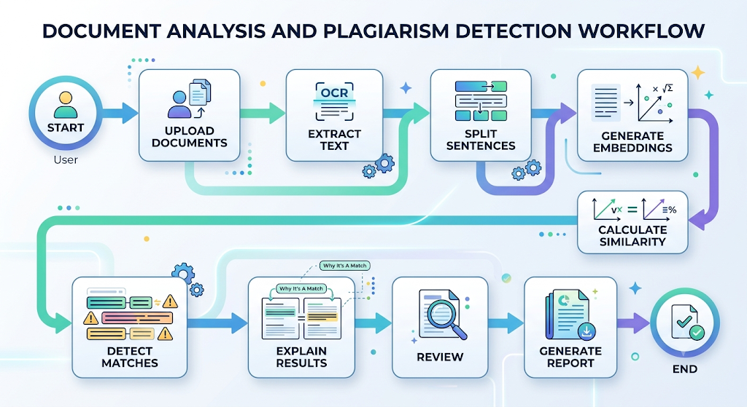

5. System Architecture
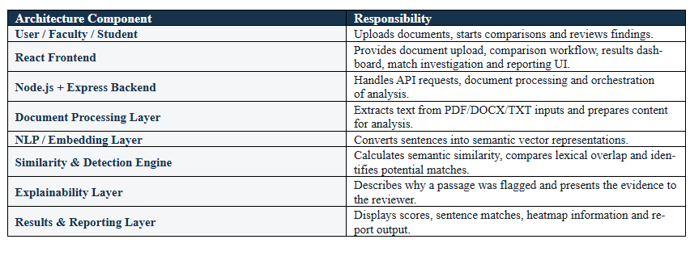
The system is organized into presentation, application, NLP/AI, analysis and reporting layers. This separation makes the application easier to maintain and allows the semantic analysis engine to evolve independently from the user interface.
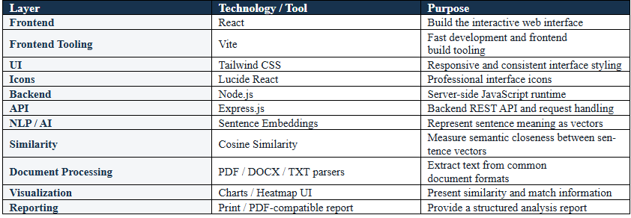
6. Technology Stack

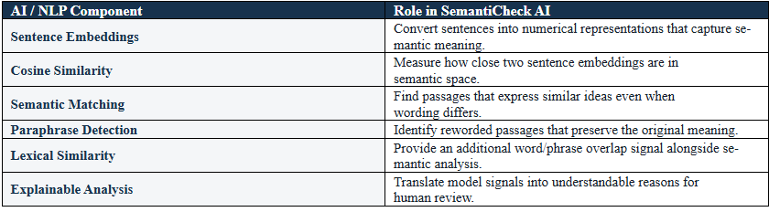
7. AI / NLP Tools and Techniques Used
8. What We Developed
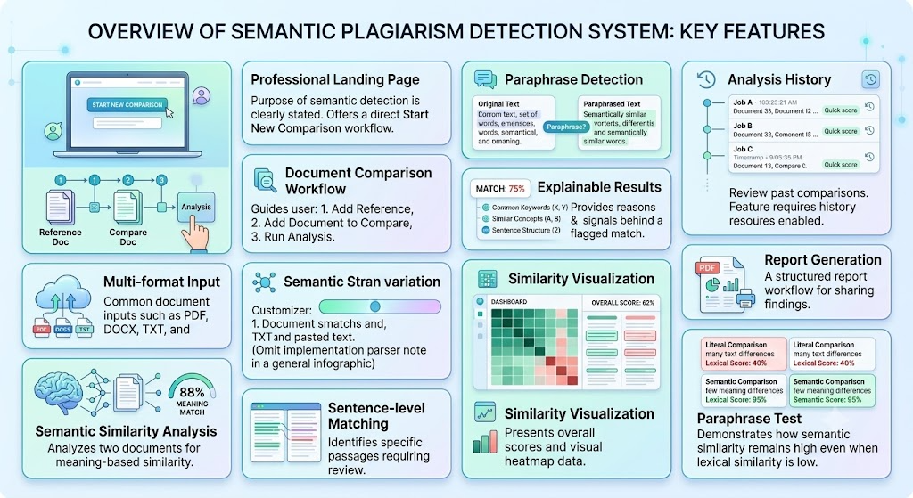
A working web-based prototype of SemantiCheck AI was developed with a professional, user-centred workflow. The application is structured around one primary task: compare two documents and investigate suspicious similarity.

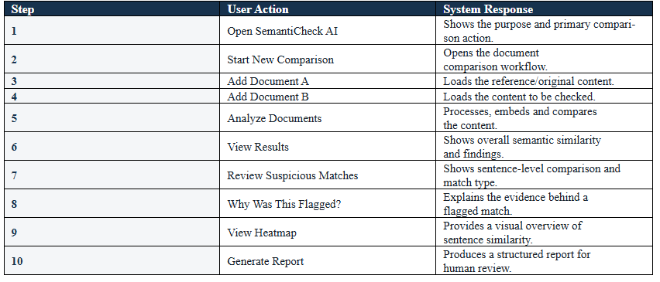
9. User Journey

10. Key Features
- Meaning-based semantic plagiarism detection.
- Sentence-level similarity analysis.
- Paraphrase and rewording detection.
- Lexical + semantic similarity signals.
- Explainable match classification.
- Interactive similarity visualization.
- Document comparison workflow with clear next steps.
- Multi-format document support.
- Analysis history and report workflow.
- Competition-ready demonstration using a controlled sample comparison.
- Relationship between files/documents
11. Differentiation from Conventional Plagiarism Checking
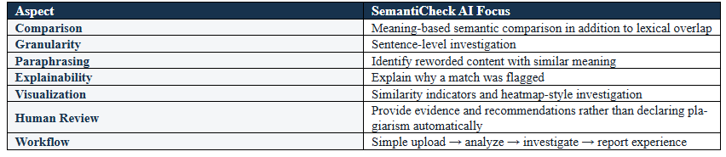
SemantiCheck AI is not positioned as a replacement for established large-scale plagiarism platforms. Its project focus is an explainable, sentence-level semantic investigation experience.

12. Expected Benefits
- Helps faculty identify potentially suspicious paraphrased content faster.
- Makes similarity results easier for non-technical users to understand.
- Reduces dependence on exact phrase matching alone.
- Provides evidence at sentence level for manual investigation.
- Creates a foundation for institutional academic-integrity workflows.
- Can be extended to multilingual and larger-scale document repositories.
13. Future Scope
- Multilingual semantic plagiarism detection across Indian and international languages.
- Cross-document and class-wide similarity networks.
- Source discovery and external reference matching.
- Institutional submission repository for historical comparisons.
- Advanced sentence splitting/merging detection.
- Improved paraphrase classification using stronger language models.
- Role-based faculty/student/institution dashboards.
- Cloud deployment and scalable processing for large document collections.
14. Conclusion
SemantiCheck AI addresses the challenge of plagiarism that can remain hidden when copied content is heavily reworded. By combining semantic embeddings, similarity analysis, sentence-level matching and explainability, the project transforms plagiarism checking from a simple similarity score into an investigation workflow.
The developed prototype emphasizes clarity and usability: users upload two documents, analyse them, inspect suspicious matches, understand why they were flagged and generate a report. This approach provides a practical foundation for an academic-integrity platform while keeping human review at the centre of the final decision.

